**Project 6: Chatbot Deployment with IBM Cloud Watson Assistant**

**PHASE-4**

**Build a chatbot**

"In this project, we are planning to create a plot booking chatbot named **Real Estate**, and here are some of its features:"

**1.Find a place to book our plot:** Provide users with a comprehensive list of plot places, on our personal wish.

**2.plot Selection:** Enable users to choose their preferred plots

**3.select cost:** Enable the user to choose their preferred cost for their plots

**4.Select number of plots:** Enable the user to choose their preferred number of plots.

**5.Queries from customer side:** Customer ask their queries about their plots (eg. Is it government approved?)

**6.Sending bought plot details to their mail:** Send entire plot details to their mail.

**Create a chatbot**

After launching Watson assistant set up your chatbot assistant.

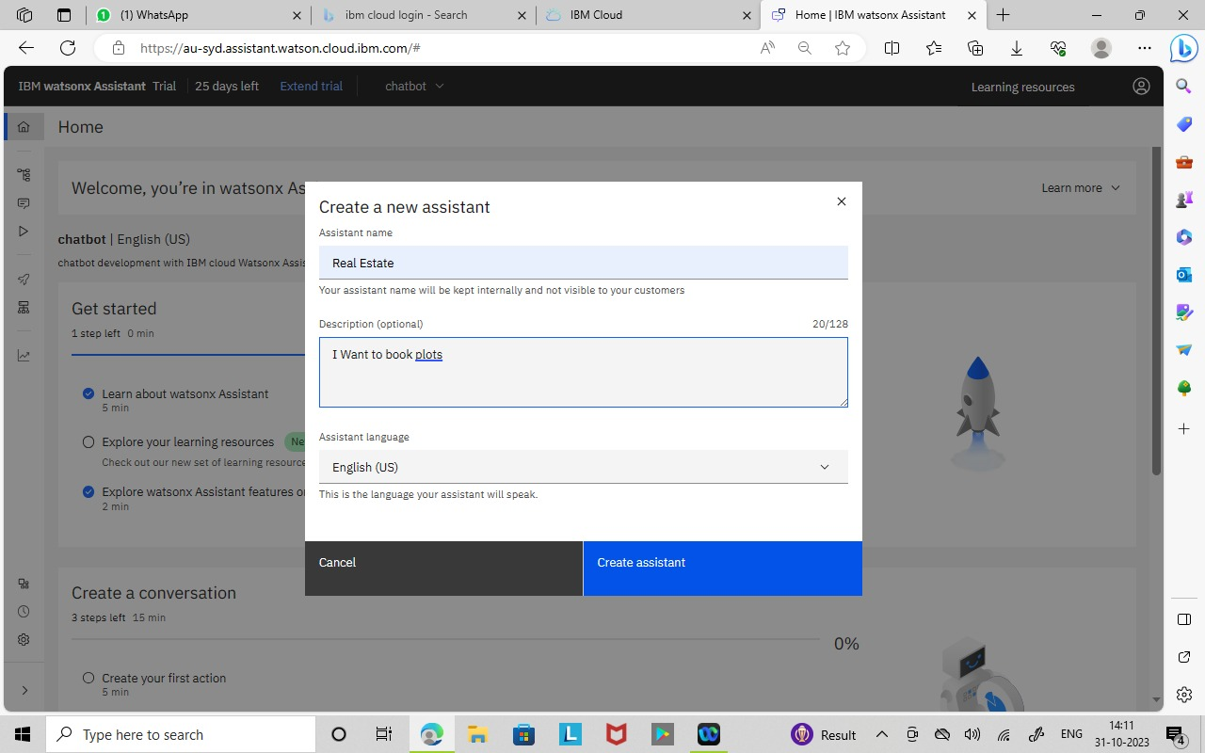

**Setup action**

Train your assistant by creating actions.

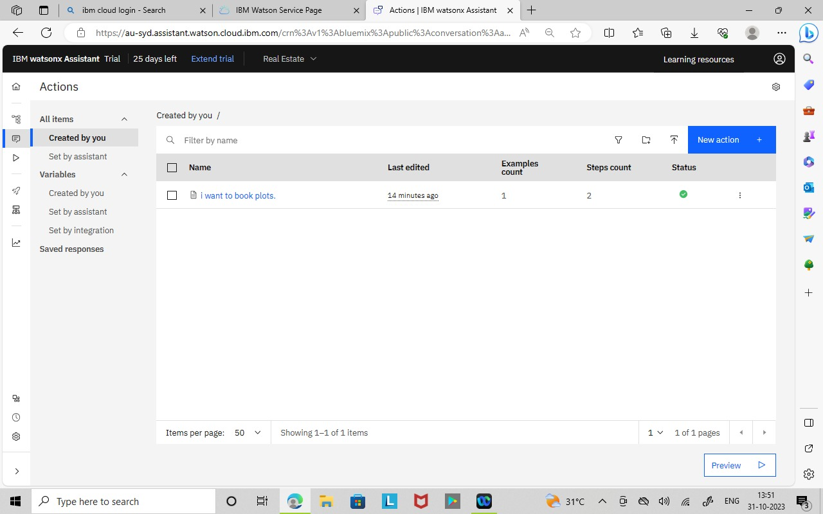

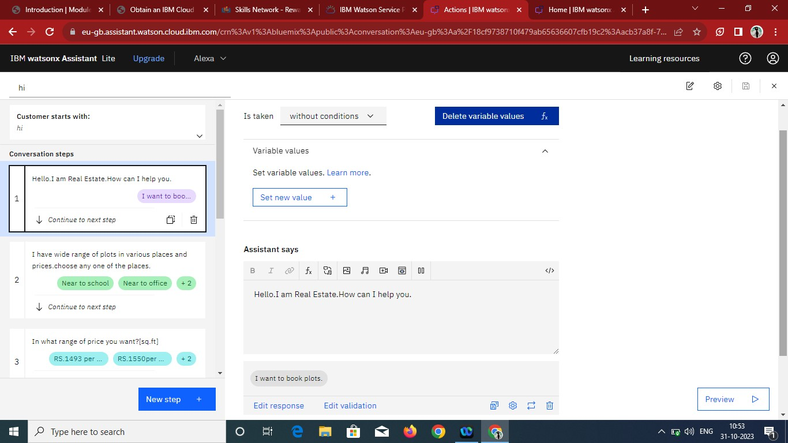

**Preview**

After completing feed actions to your chatbot use preview option for

viewing our chatbot.

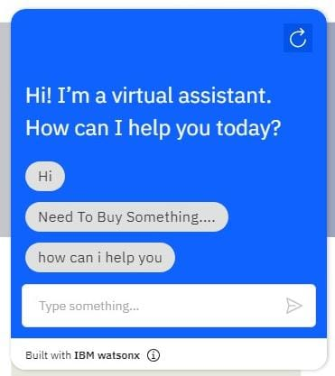

**Preview link for our chatbot:**

<https://web-chat.global.assistant.watson.appdomain.cloud/preview.html?backgroundImageURL=https%3A%2F%2Feu-gb.assistant.watson.cloud.ibm.com%2Fpublic%2Fimages%2Fupx-acb37a8f-71f8-4a11-8c49-8478eb50adb8%3A%3A61a758f8-1340-4793-873b-34b65d912bcb&integrationID=907c50d2-3211-415b-be00-8f9e6df3e09d&region=eu-gb&serviceInstanceID=acb37a8f-71f8-4a11-8c49-8478eb50adb8>

**Screen shots:**

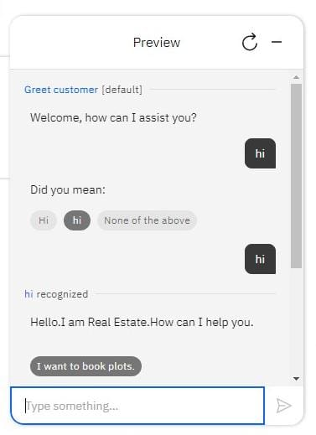 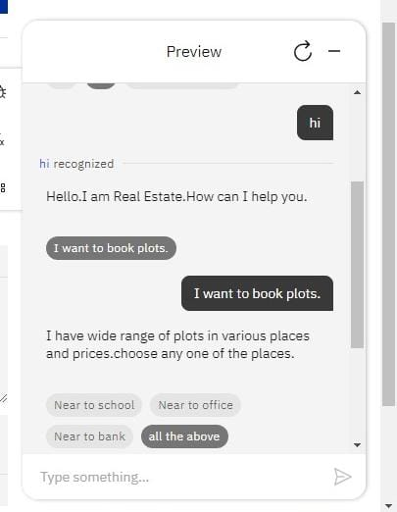

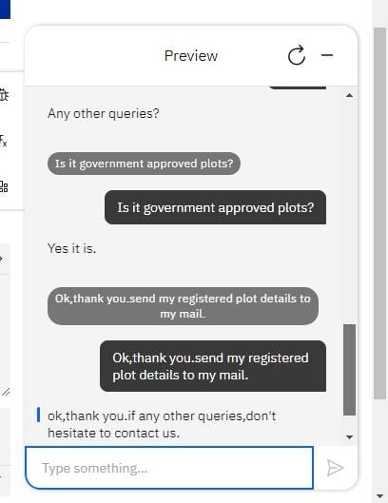 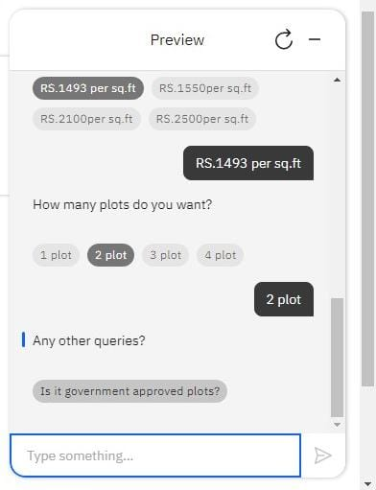



**Development part 2**

**Building a chatbot by integrating it with messaging platforms and**

**refining the process.**

**Create a Watson Assistant Skill:**

• Log in to your IBM Cloud account and access IBM Watson Assistant.

• Create a new skill or use an existing one.

• Build your chatbot using the IBM Watson Assistant's service.

• Train your chatbot by providing example user inputs.

**Set Up Integration:**

• In your Watson Assistant skill, navigate to the "Options" menu and select

"Integration."

• Click to the “Channels” and view messaging platforms.

**Configure the Messaging Platform:**

• Selecting a platform for example Facebook messenger

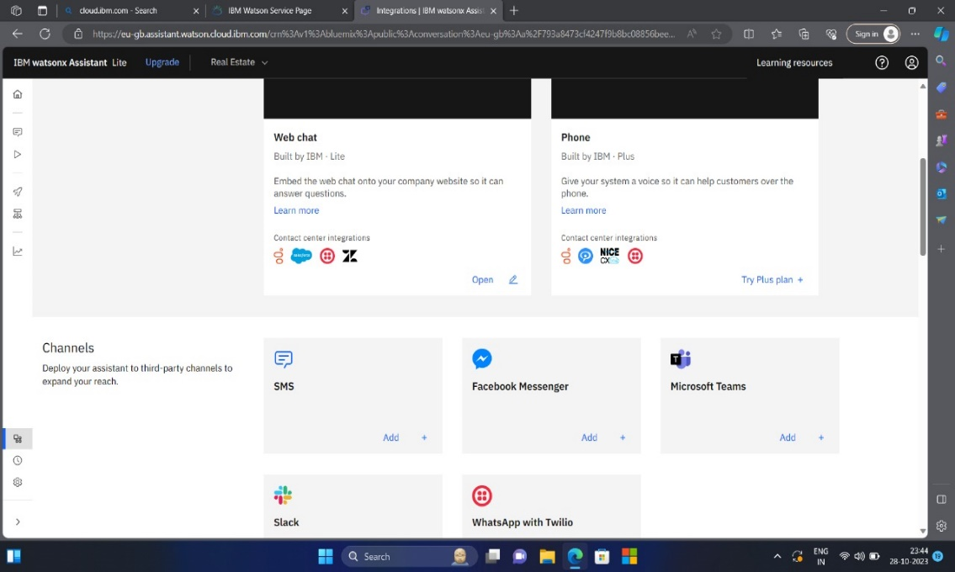

**Creating a Facebook application**

• Go to Facebook for developers and log into Facebook account.

• Register a developer account and add necessary details complete

registration.

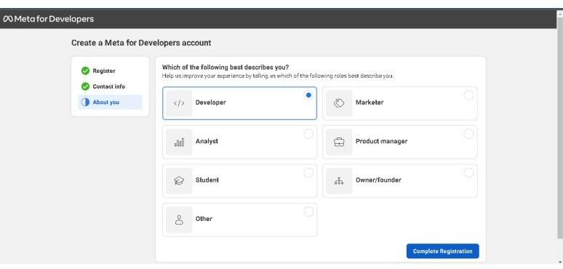

**Creating an app**

• Click Add a New App and complete the steps to create a new app ID.

• Add app name and contact details for create an app

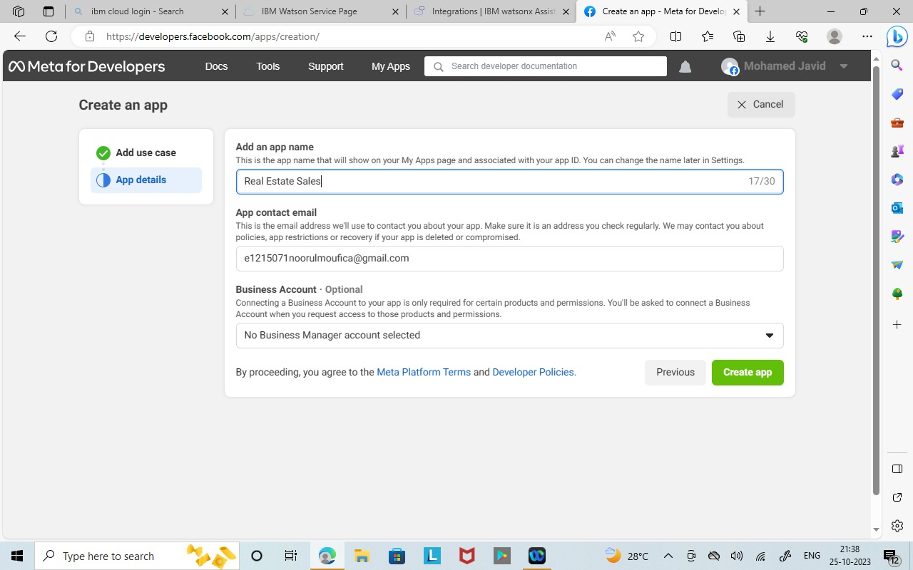

• In the dashboard, click App settings select Basic.

• Select App Secret, click Show. Copy the app secret.

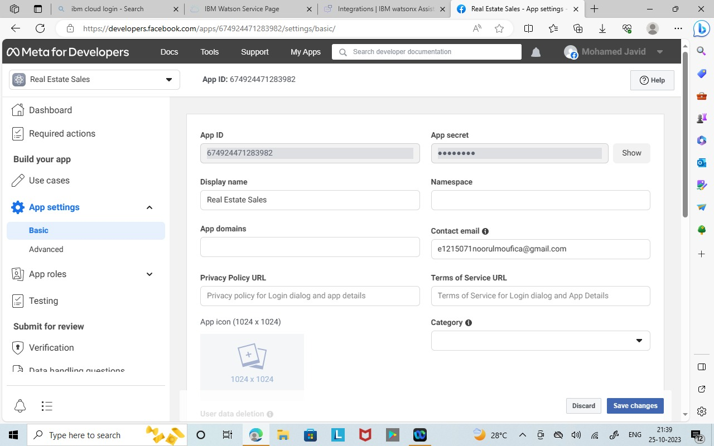

• Copied app secret pasted into IBM Watson assistant Facebook messenger

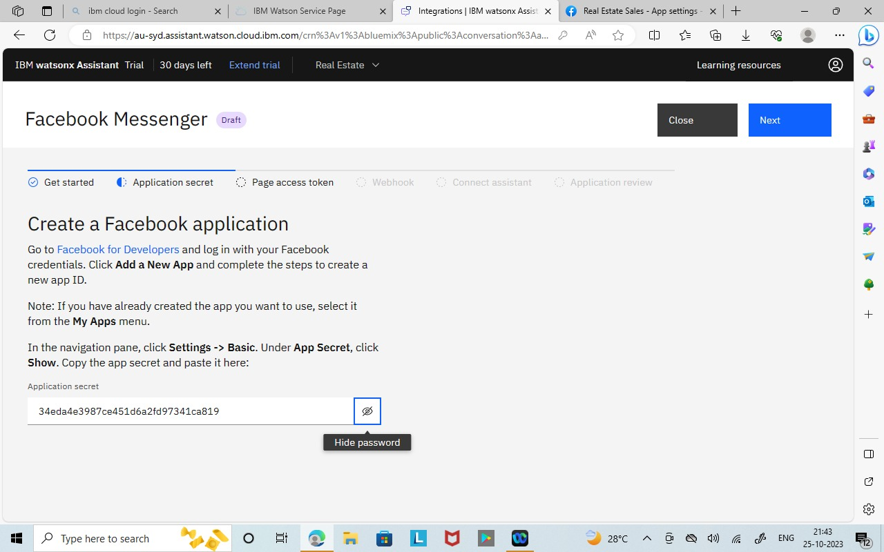

**Creating a Facebook page**

• On the Facebook app page, click the Products in the left side navigation.

• find the Messenger tile and click Set Up

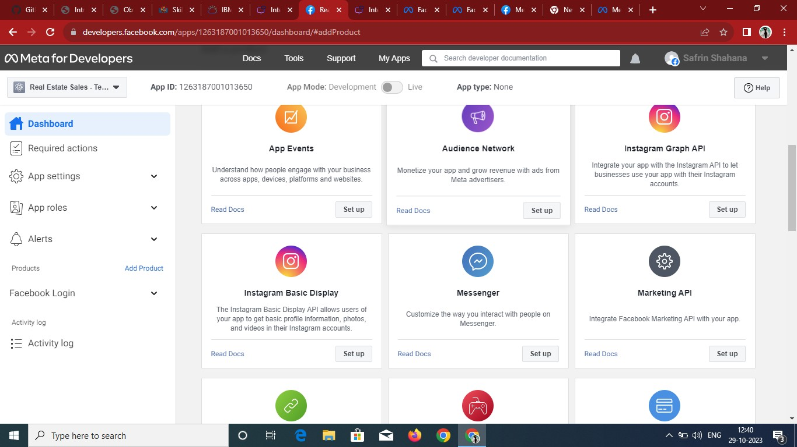

• Click Add or Remove Pages and choose the Facebook page you want to use

for your app.

• Click Generate Token and check the I Understand checkbox to generate the

page access token

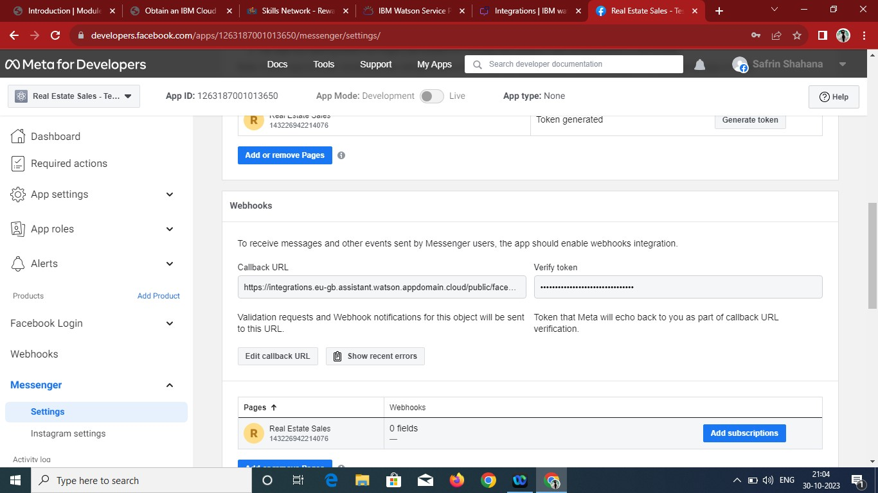

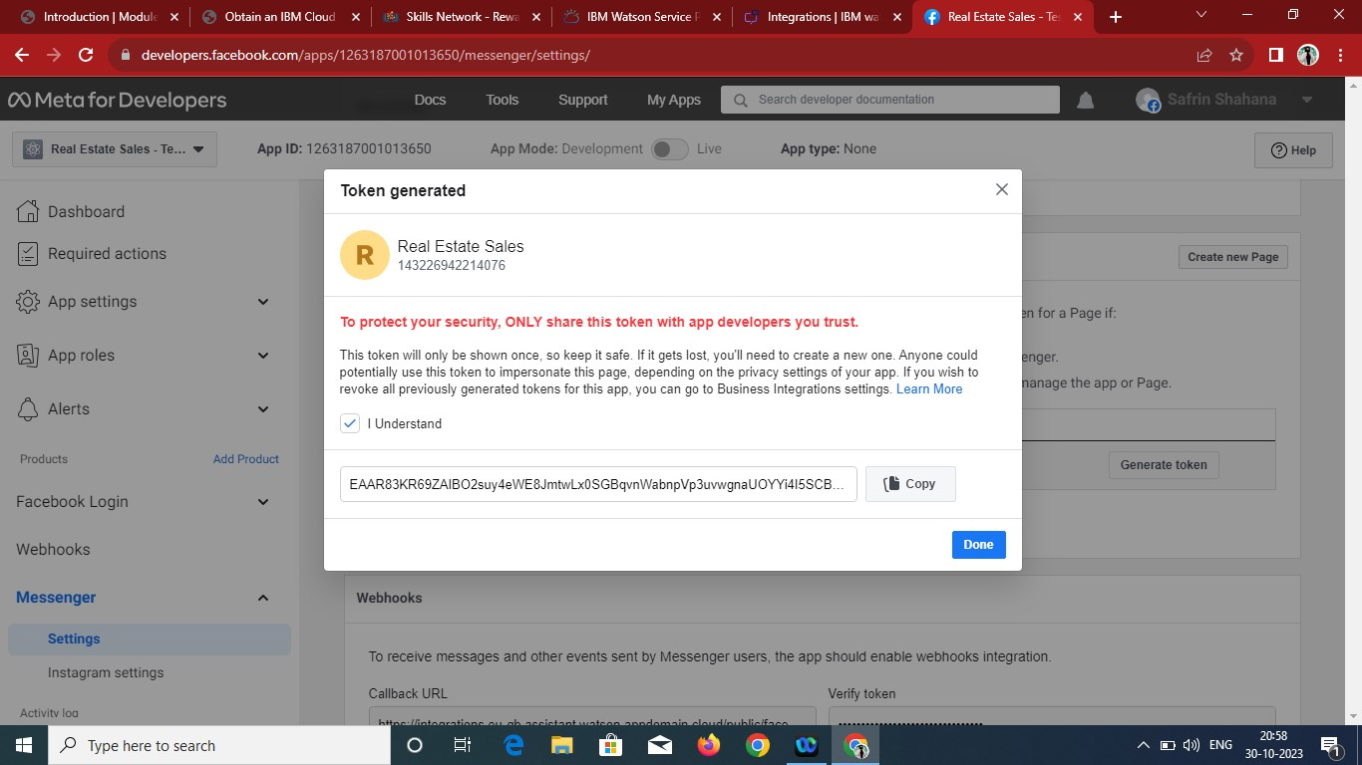

• Copy the page access token and paste into IBM Watson Facebook

messenger page.

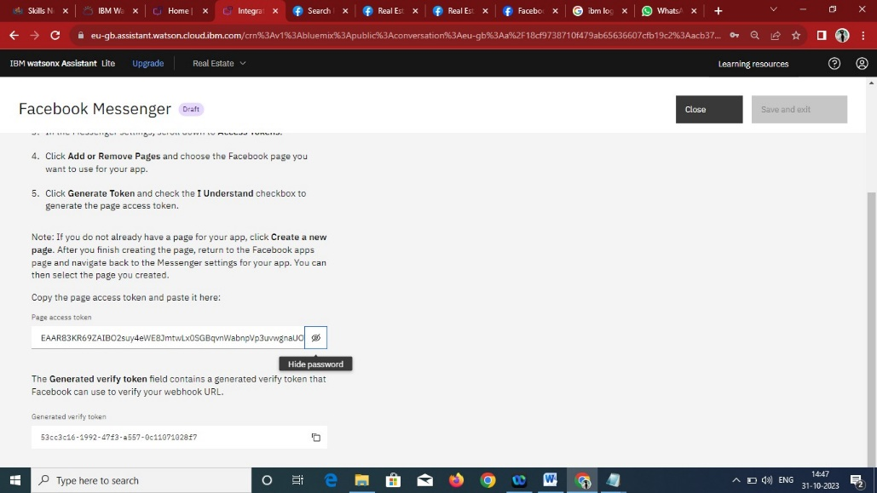

**Configure Facebook webhooks**

• Copy the generated URL in IBM Watson Facebook messenger

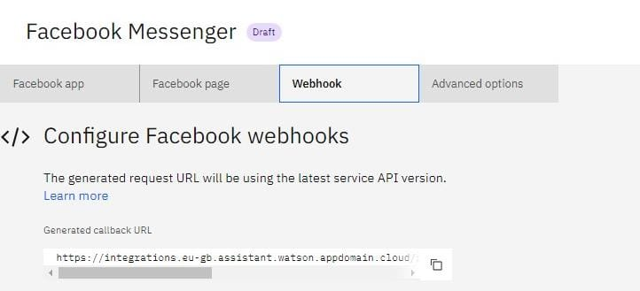

• In the Meta developers Facebook Messenger settings, scroll to the

Webhooks section. Click Setup Webhooks.

• In the Edit Callback URL window, paste the generated callback URL into

the Callback URL field.

• In the Verify Token field, paste the verify token that was generated for you

in Facebook page in IBM Watson Facebook messenger page.

• Click Verify and Save

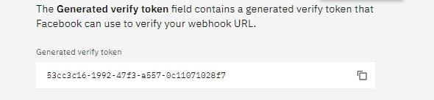

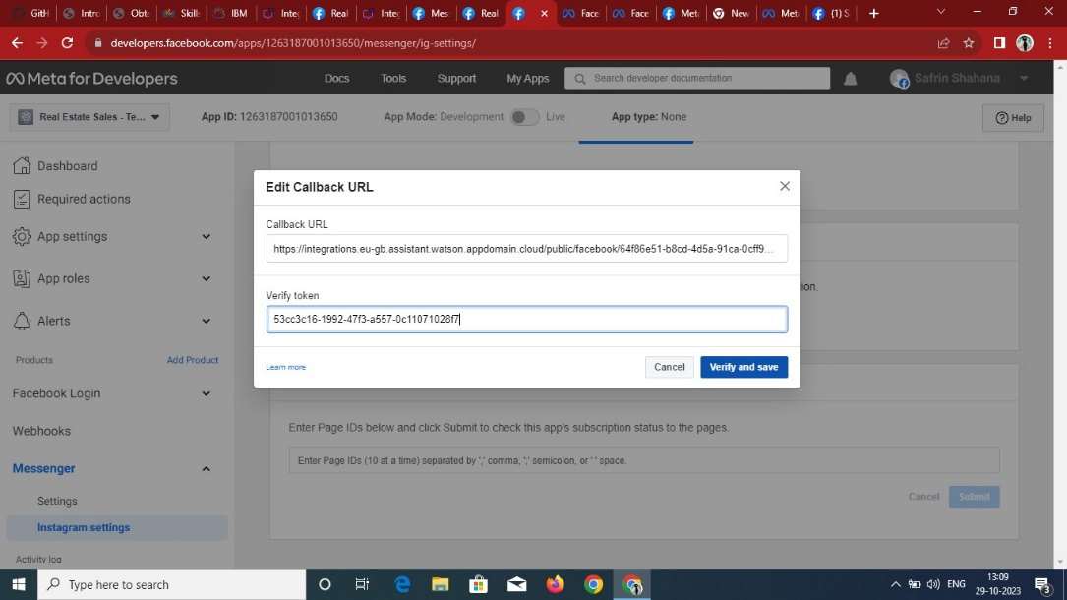

• Click Add Subscriptions. In the Edit Page Subscriptions window under

Subscription Fields, select messages and messaging_postbacks. And click

Save

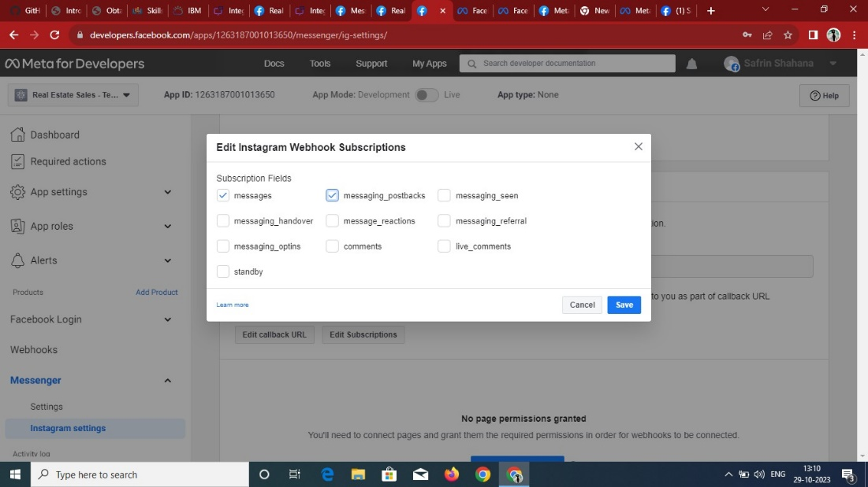

**Connect your assistant**

• After successfully completing the above procedure, your chatbot is now

successfully integrated into messaging platforms like Facebook Messenger

**screenshots:**

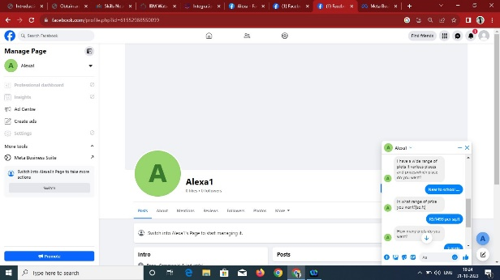 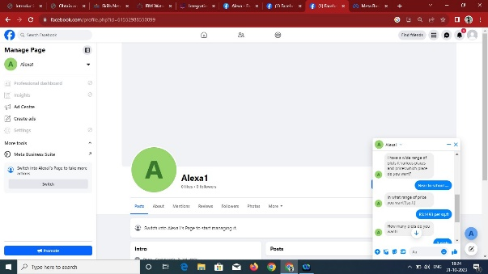

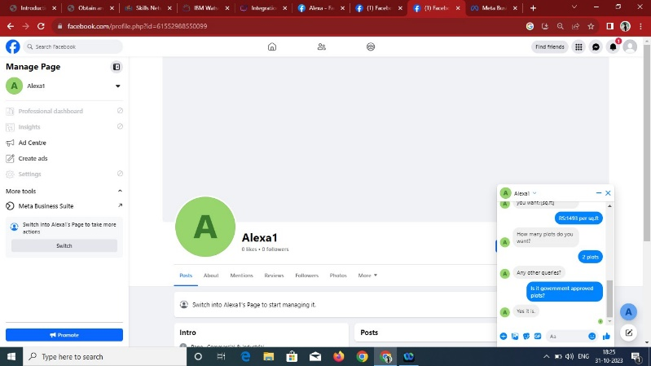

**INTEGRATING CHATBOT WITH SLACK:**

Step 1: Select Slack Add+

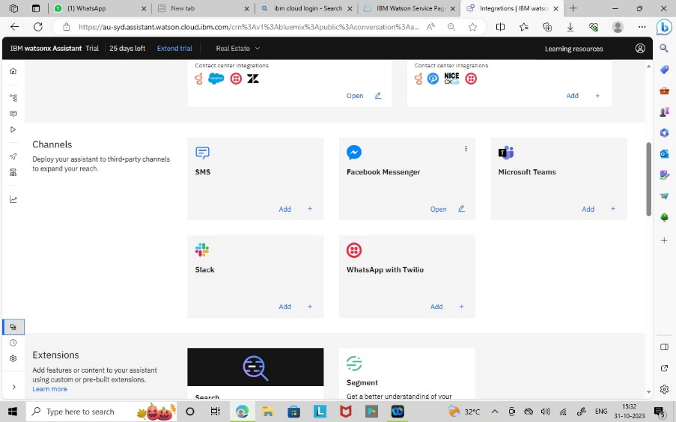

Step 2: Start the Setup for Integrating slack to IBM Watson Assistant

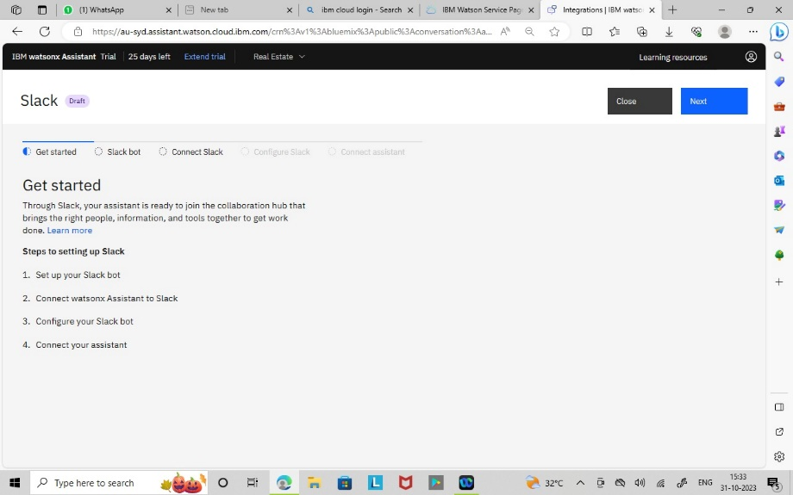

Step 3: Create a Slack app and open your apps page

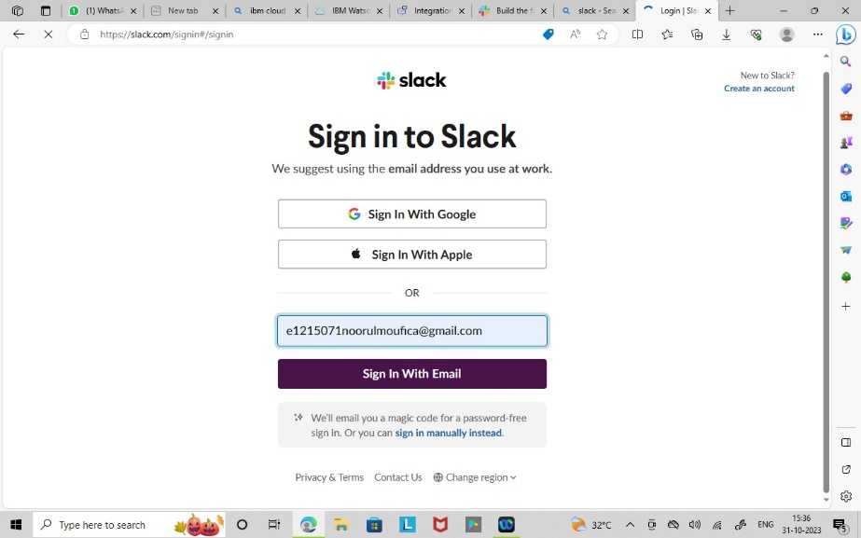

Step 4: Create a app and add the chatbot in the workspace

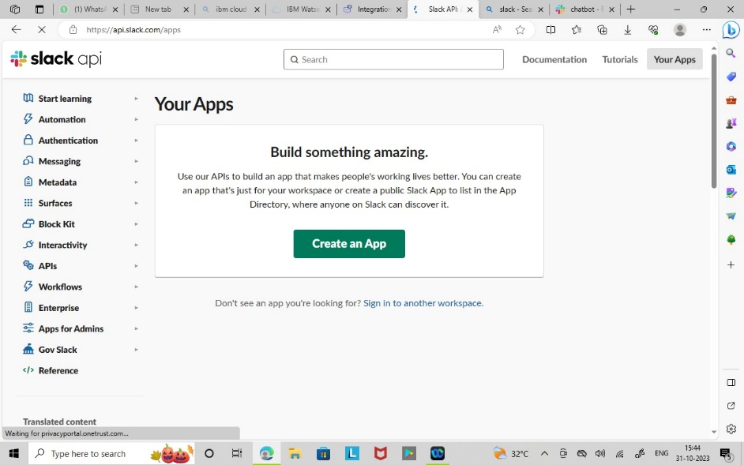

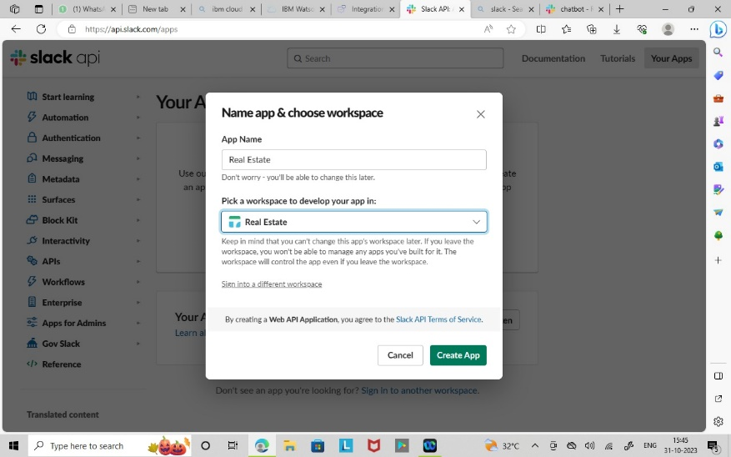

Step 5: On the Slack app settings page, go to the Basic Information tab and find the App Credentials section. Copy your verification token from that section to the field below

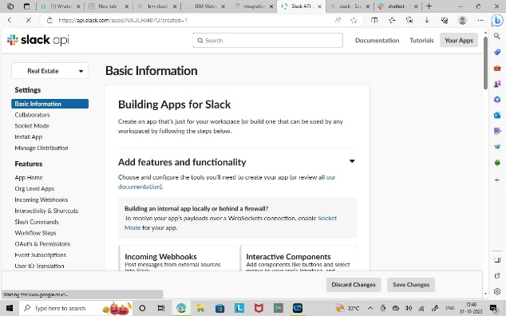 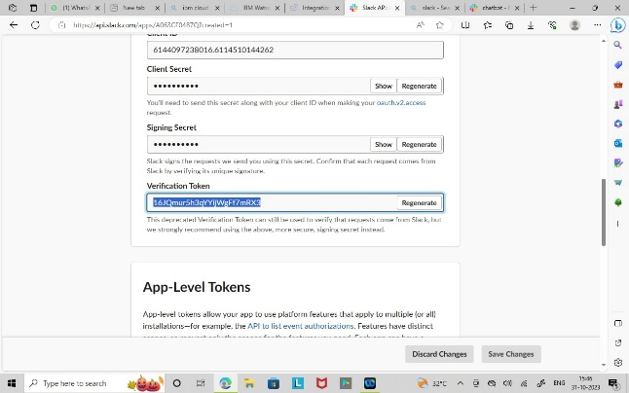

Step 6: Go to the OAuth & Permissions tab. In the Bot Token Scopes section click Add an OAuth Scope, and then select the following scopes:

• app_mentions:read

• chat:write

• im:history

• <im:read>

• <im:write>

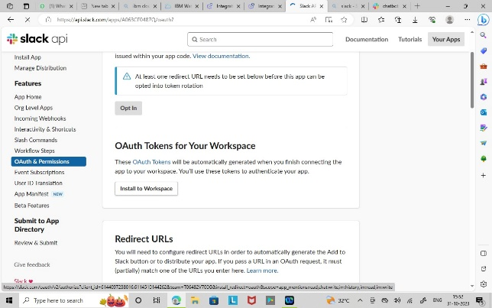 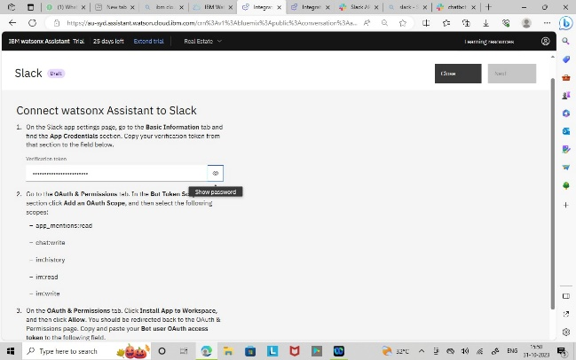

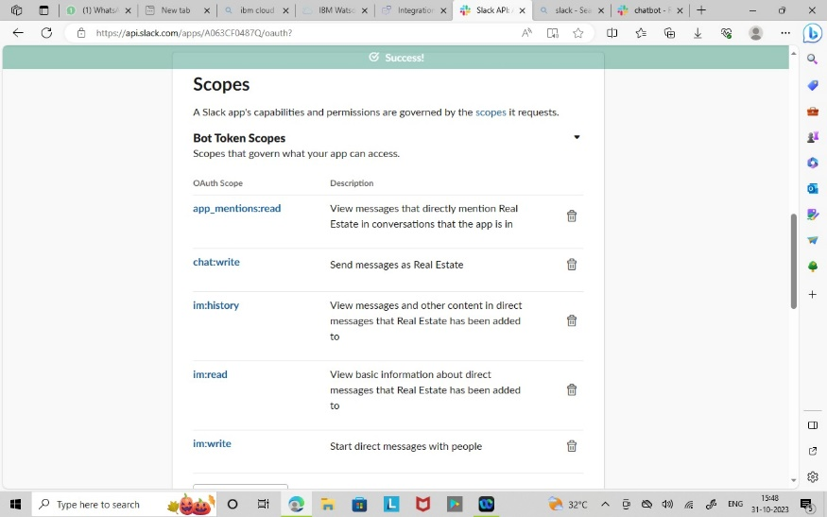

Step 7: On the OAuth & Permissions tab. Click Install App to Workspace, and then click Allow. You should be redirected back to the OAuth & Permissions page. Copy and paste your Bot user OAuth access token to the following field

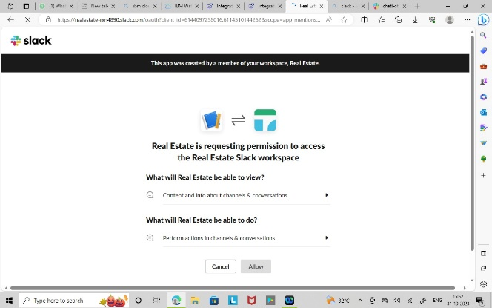 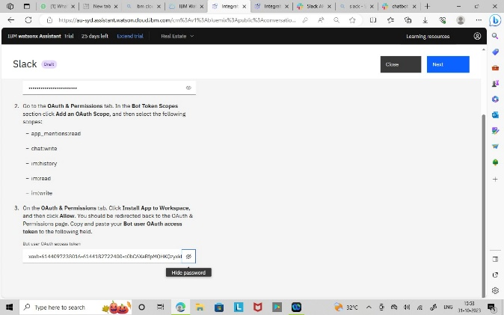

Step 8: On the Slack app settings page, go to the Event Subscriptions tab. Switch the Enable Events toggle to the On position. In the provided text entry field, paste your request URL

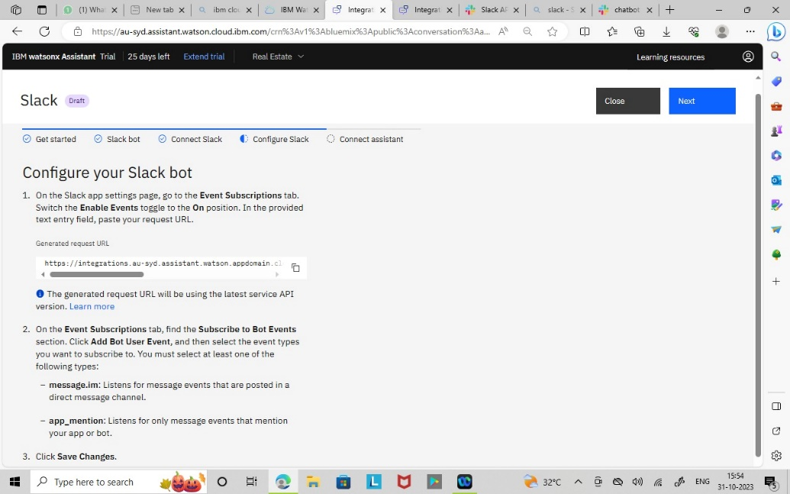

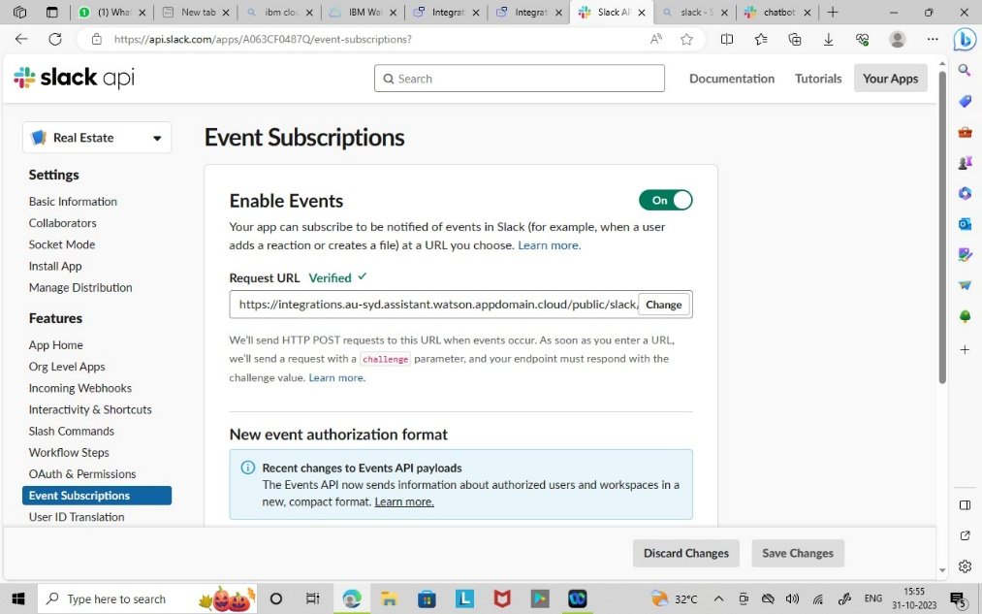

Step 9: On the Event Subscriptions tab, find the Subscribe to Bot Events section. Click Add Bot User Event, and then select the event types you want to subscribe to. You must select at least one of the following types:

**1.message.im:** Listens for message events that are posted in a direct message channel. **2.app_mention**: Listens for only message events that mention your app or bot

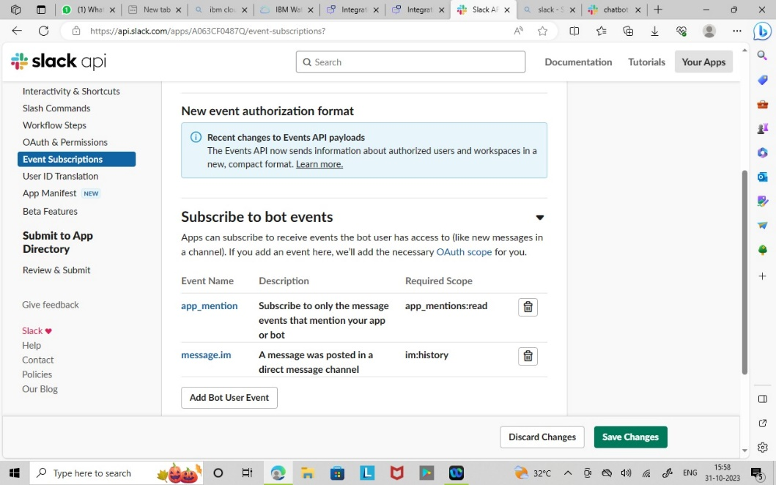

Step 10: On the App Home tab, click Edit and enter a display name and default username for your virtual assistant and then click Save. Enable the Always Show My Bot as Online toggle

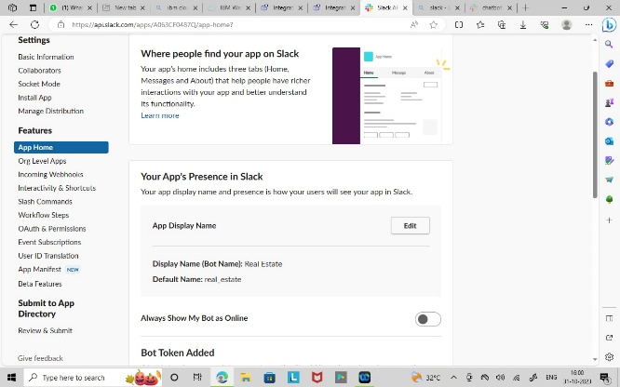 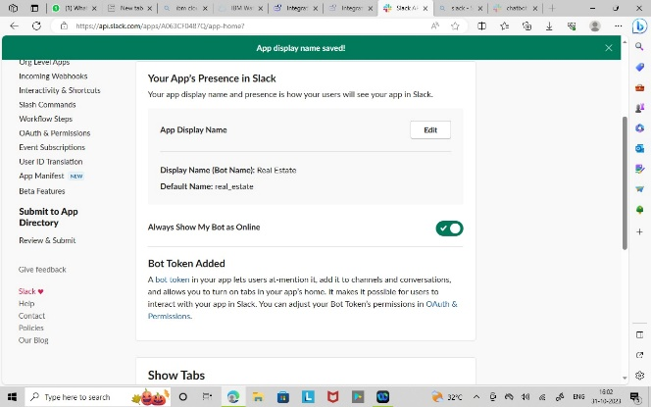

Step 11: On the App Home tab, find the Show Tabs section. Enable the Messages Tab toggle and check the Allow users to send Slash commands and messages from the messages tab checkbox.

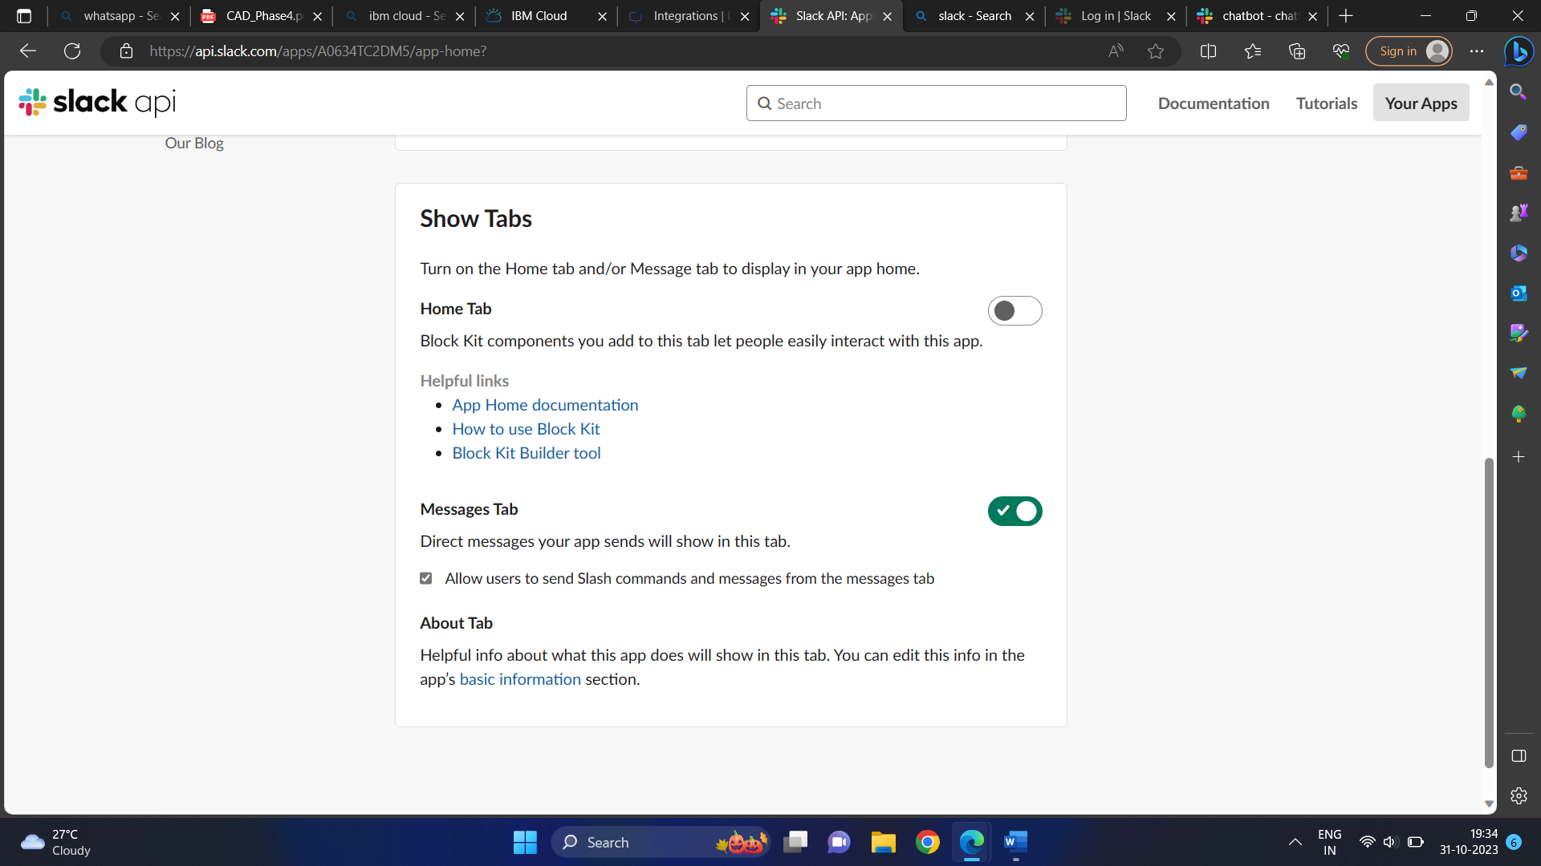

Step 12: To add support for showing buttons, menus, and disambiguation options in the Slack app, go to the Interactivity & Shortcuts tab and enable the feature. Paste your request URL in the provided text entry field, and then click Save Changes.

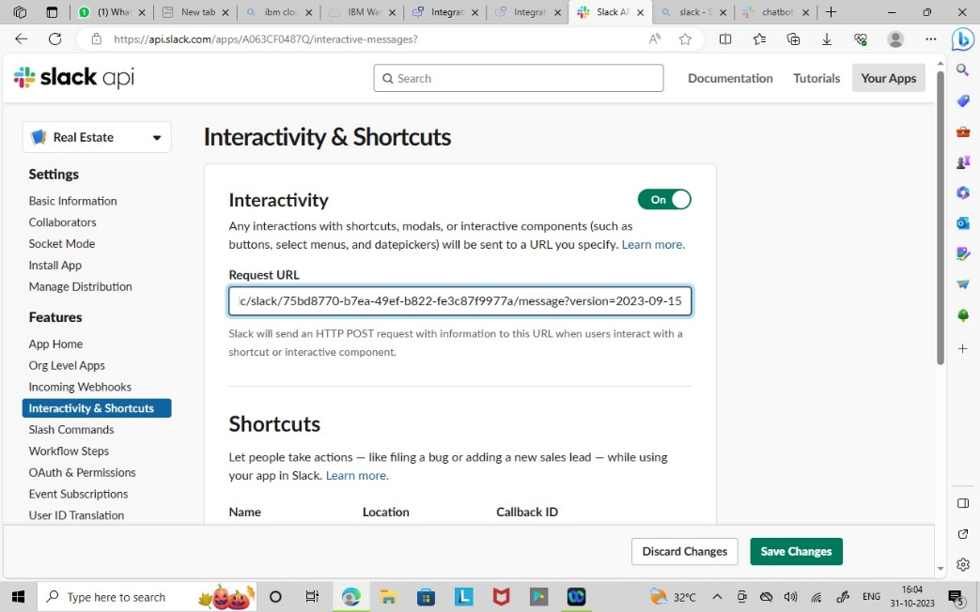

Step 13: Create a channel and review the chatbot.

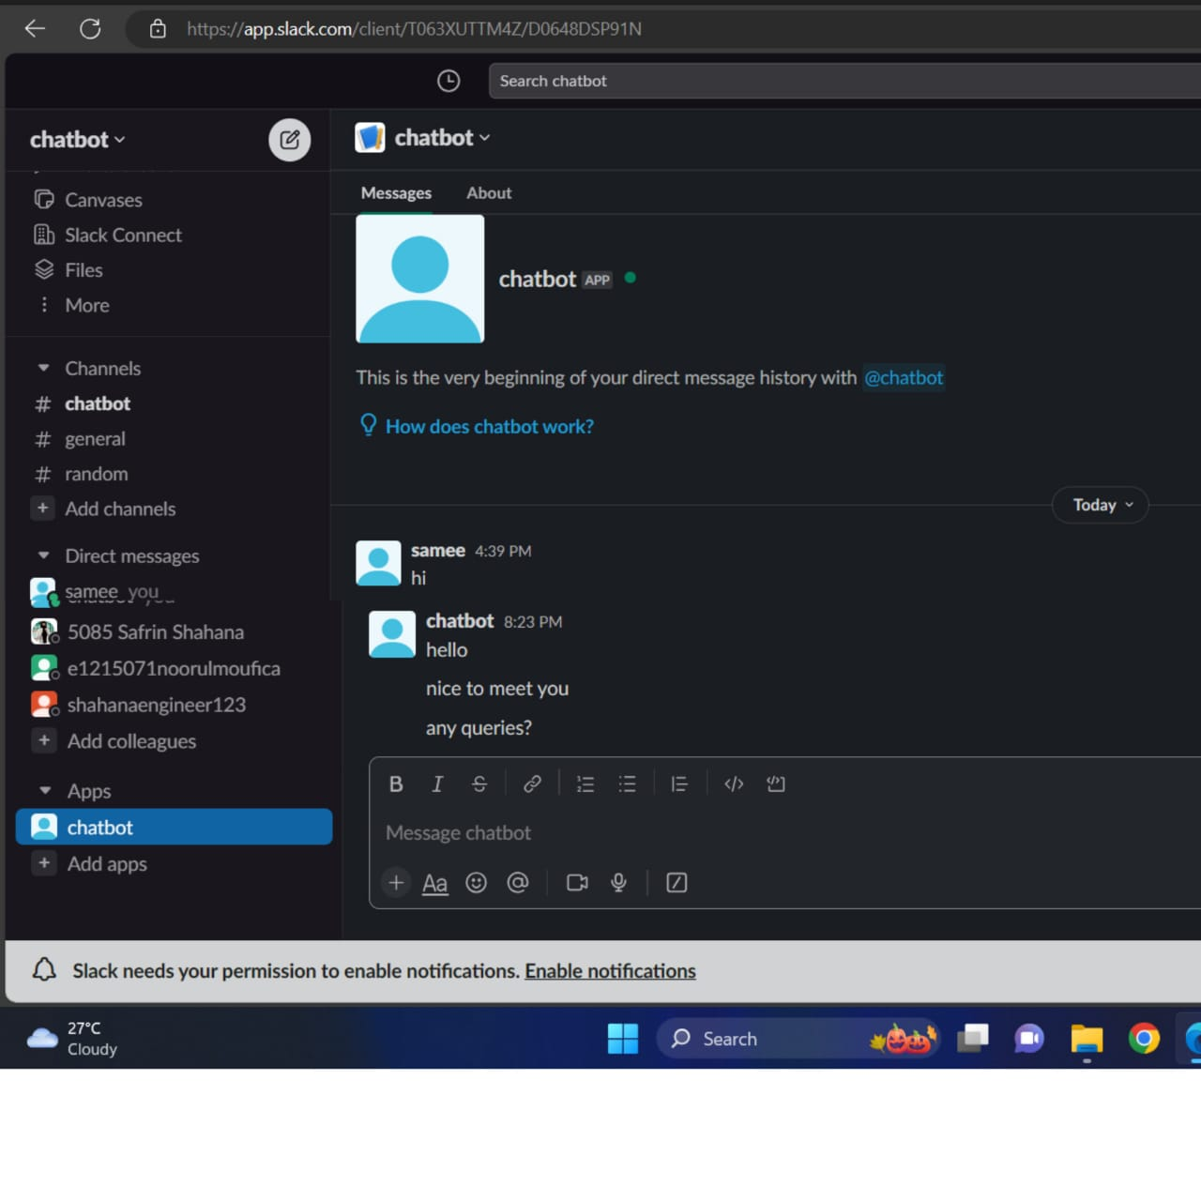

**CONCLUSION:**

Thus the integration of chatbot with Facebook Messenger and Slack using respective APIs. Ensure that the conversation flows naturally and that the chatbot's responses are informative and accurate has been done successfully.